James Rushing

Final Report

Etching experiments for selective etchant for ingaas over inalas in the 111

06-07-23

Summary of where I picked up the project and where I am leaving it.

When I started helping with the project, Jay already had samples ready to etch. My first part in the project was running the profilometer while jay cycled through 1 minute etches. From the very first attempt at this, it was clear that the methods that we were employing on the profilometer were not replicable from etch to etch and that the data we were collecting had orders of magnitude higher error than necessary to record nanometer scale etch rates. It occurred to me that the photoresist layer was nowhere near uniform enough to record apples to apples step heights from etch to etch. Below I will summarize my thoughts on why this was the case.

When jay left, I began to rebuild the project from scratch. Here are a few things that I had to change to procure reasonable data:

NUMBER 1 (etch chemistry):

Below is a table from the research that suggested these chemicals could be selective in the way that we desired. After reading up on this, it occurred to me that my predecessors were using SA, which only suggests a 2:1 selectivity, which is nowhere near what is needed for our purposes. It should be noted that all this work was done on the 100, and there is no promise that there will be a one-to-one correspondence to our 111 work. Nevertheless, it is clear from the table below that the most likely candidate would be DSA.

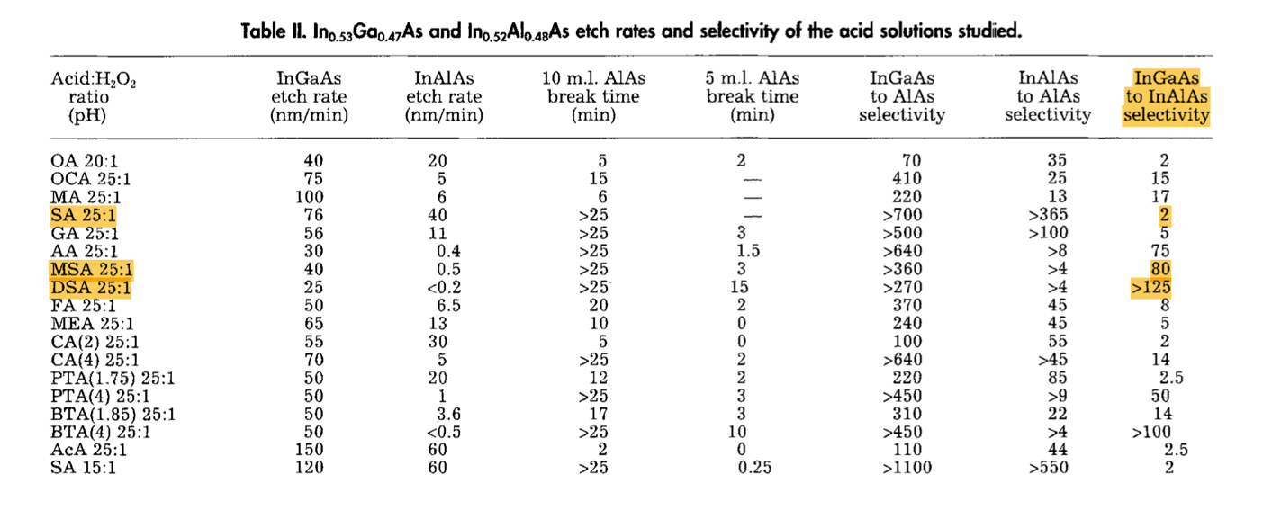

**Novel, OrganicAcid-BasedEtchantsfor InGaAIAs/InP HeterostructureDeviceswith AlAs Etch-StopLayers TomP. E. Broekaertand CliftonG. Fonstad\***

NUMBER 2 (sample preparation):

After many attempts to execute the methods in the SOP for preparing the wafers it became clear that this was a fool’s errand. The following is what I discovered:

1. The diminutive size of our wafers makes spin-coating photoresist exceedingly difficult. The wafers are too small to vacuum suction onto the spin coater. I later learned that my predecessors were using double sided tape to secure the wafer during spin coating. This did not occur to me to be replicable. Furthermore, as I later learned, even if you can keep a small wafer down during ~3000 rpms, the photoresist will not be uniform. The edges will be raised. This adds error to profiling data but, what is more, it makes using the mask aligner impossible. Having a raised, non-uniform, edge around the samples means that when exposing the positive photo-resist to the UV light will seep in and make the photoresist solvable in all the wrong places. I believe this is the reason for the bag of failed photoresist samples left by my predecessors.
2. The SOP directs us to use the ellipsometer to measure the height of the photo resist using a recipe that is formulated for a silicon substrate. As our substrates are InP (111) the optical properties are completely different. This mean that we would need to write a new recipe or find another way to estimate the photoresist height. This could be another reason for the bag of failed photoresist samples left by my predecessors. The height of the photo resist determines the exposure time.

NUMBER 3 (characterization):

The use of the profilometer is non-trivial and impossible to perform on-the-fly alongside the etch experiments. Through trial and error, I learned that it takes more than ten times as long to properly profile a sample than it does to etch the samples, making a synchronous experiment impossible. Here are a few problems with our use of profilometer:

1. Taking a left, right, and center measurement doesn’t provide a good average when the step heights aren’t uniform. Furthermore, if the photoresist isn’t nanometer flat, how far you choose to scan into the sample (the x-axis) will also disguise any results in the noise.
2. Between etches, the samples look very different. Left, right and center are not good indicators if they aren’t the same from etch to etch, for example, if a piece of resist flakes off.
3. The change in z-height (shown below) does not average the red and green areas. It only subtracts R from M. To see the average, you must right click and hit “show watch list.”

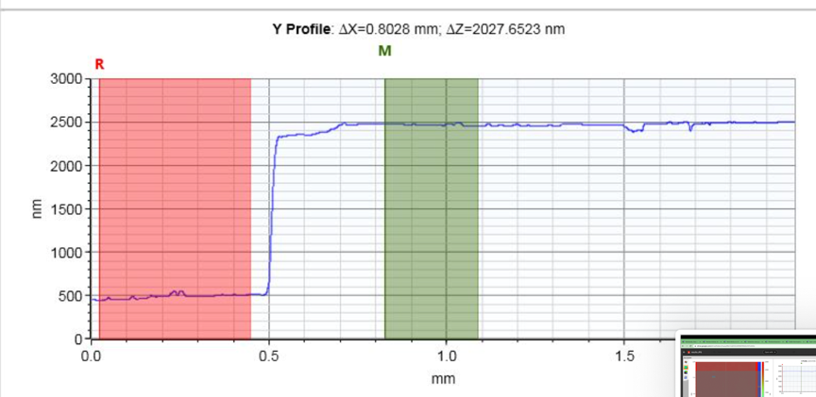

1. Setting up single scans is time consuming. Using the Map-scan feature on the profilometer can provide more data in less time.

Addressing NUMBER 1 was a matter of purchasing a new chemical. This was bureaucratically laborious but scientifically uninteresting.

I attempted many techniques for resolving NUMBER 2 and NUMBER 3. I am going outline the successful ones here. I was able to resolve many of these issues at once with a new method of applying photoresist. This method involved deposing the tiny blobs onto the wafers. I tried to use a micropipette to dispense the blobs but found that, even on the smallest setting (~.2microliters), this produced blobs that were too large. Instead if you simply dip the smallest plastic pipette fitting into the photoresist and blot it on, you can reliably deposit dome shaped blobs between 20 and 60 microns in height.

Below are images of the blobs from the profilometer camera, the resulting data, and images of the full samples.

Department of Electrical Engineering and Computer Science, Research Laboratory of Electronics, and  
Center for Materials Science and Engineering, Massachusetts Institute of Technology, Cambridge, Massachusetts 02139 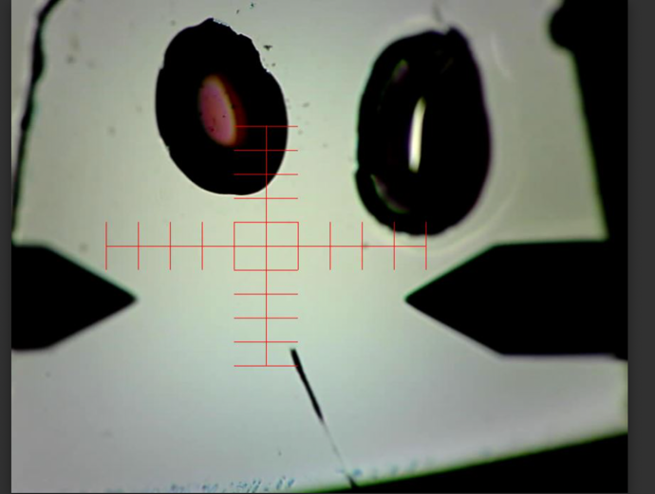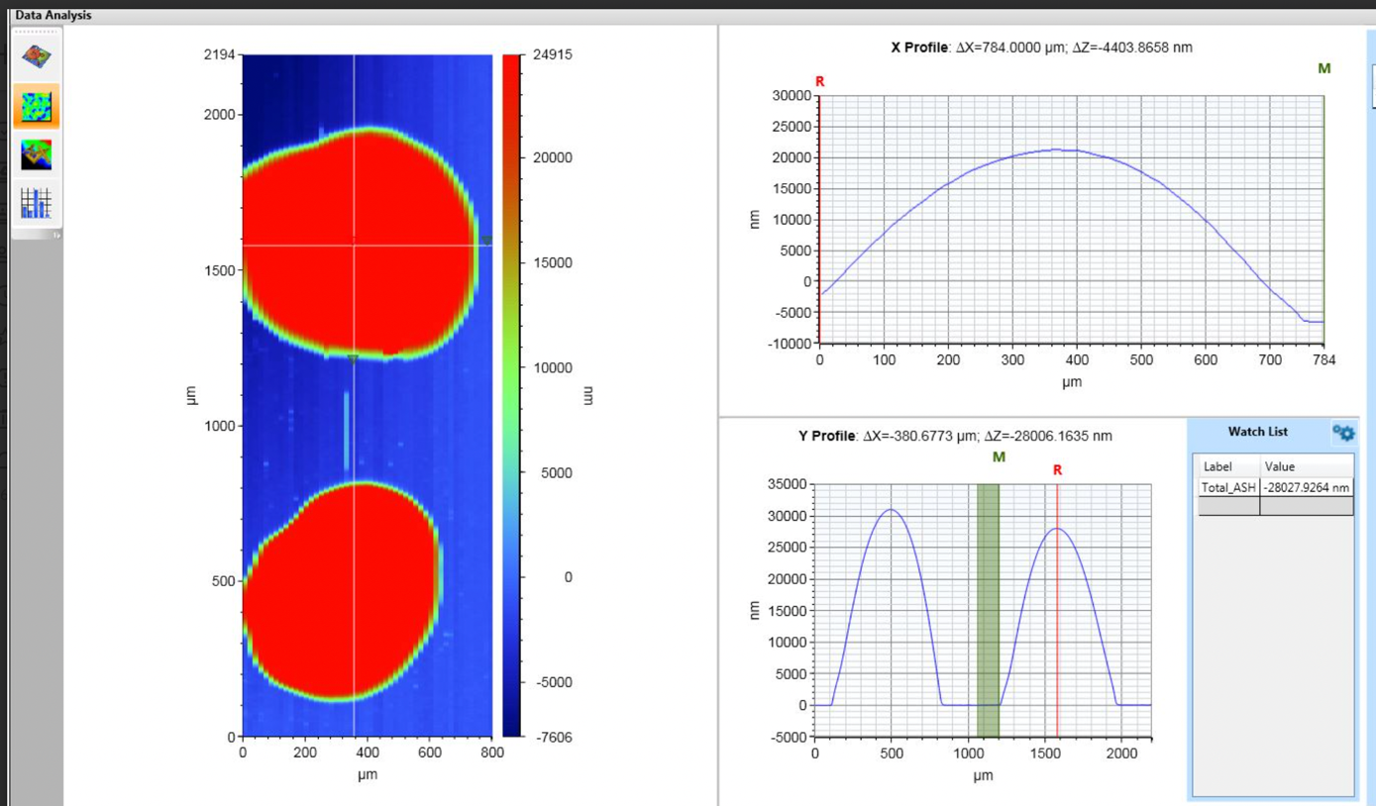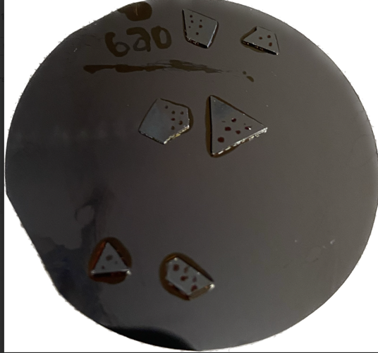

The disadvantage of this techniques is that it takes good eyesight and precise dexterity to apply the blobs. Were this project to continue, I believe a more hands-free applicator could be used. However, this technique provides many advantages.

* First and foremost, this requires no spin-coater, no ellipsometer, no mask aligner, and no use of the base bench for developing the photoresist. This cuts way down on equipment use, saving time and money. It also deletes the many gaps where inconsistent data can spring from.
* With the blobs and the mapscan feature of the profilmeter, It is trivial to make an apples to apples measurement between etches. The data above is of a mapscan with aggregate data from 50, 10 second scans. This allows you to easily scroll between the single scans of the data and locate the maximum height of the blob, which will not vary with angle of the scan or substrate. This max height can be subtracted from the max height before etching to reveal the amount etched.
* This also allows for more discrete data points per sample, with each blob being its own measurement.
* The tiny size of blobs also allows for the misapplication of crappy blobs while leaving room for more uniformly shaped blobs. The samples in the image above in the millmeter range and yet can hold many individual blobs.

Here is the way best way I have found to prepare these wafers:

Place sample wafers onto a larger scrap wafer. Apply as many blobs as you can, as it is clear under the profilometer camera which ones are nice domes. With the small wafers loosly arranged on the scrap carrier wafer place the whole bunch on the soft bake for 90 seconds at 115C. Removed the carrier wafer and place on a non metallic surface so that it cools slowly. Then hard-bake each individual sample for 30 seconds at 150C. Finally, glue the small wafers onto the large scrap wafer with photoresist by blotting photoresist on and placing the wafer on top. Be sure to press down and swirl the wafer around so that it is sitting flat on the carrier wafer and there are no bubbles under the sample. Once all the samples are glued on, soft back the whole thing for 30 seconds at 100 C to secure the samples.

RESULTS:

It appears the DSA is not a chemical that will etch InGaAs selectively over InAlAs on the 111. In in these preliminary finding, we see that, while InGaAs seems to etch uniformly and linearly across the surface at about 50nm/min, InAlAs etched trenches down to the substrate on the order of minutes. This makes DSA unsuitable for our purposes.

It is nevertheless very interesting how the samples etch. Below is the InAlAs (M644) surface profile after 6 minutes of etching. It is etching trenches down to the substrate.

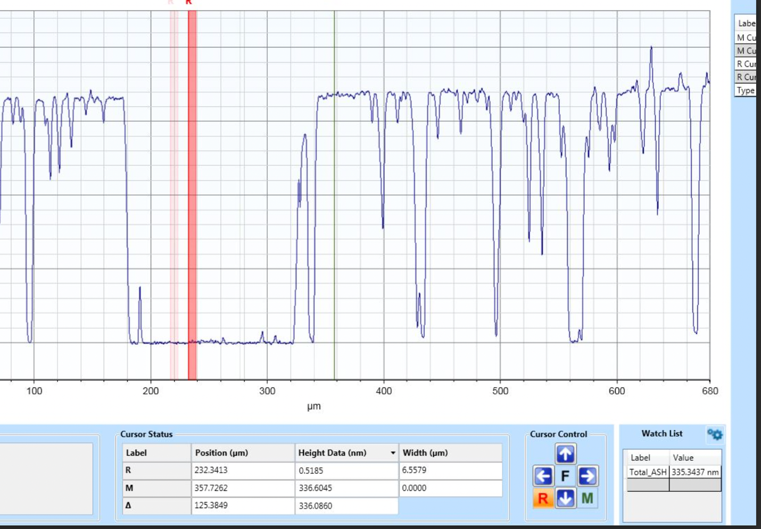

M644 was a pure InAlAs sample grown for etching purposes. We also commandeered InAlAs calibration samples and repurposed them for etching. In doing so we accidentally revealed the strain present in these samples. As can be seen in the images of M648 below, the sample etches trenches in interesting patterns that were not present in the M644 sample. The image below was after 4 minutes of etching, indicating that the etchant reaches the substrate almost immediately along the trenches.

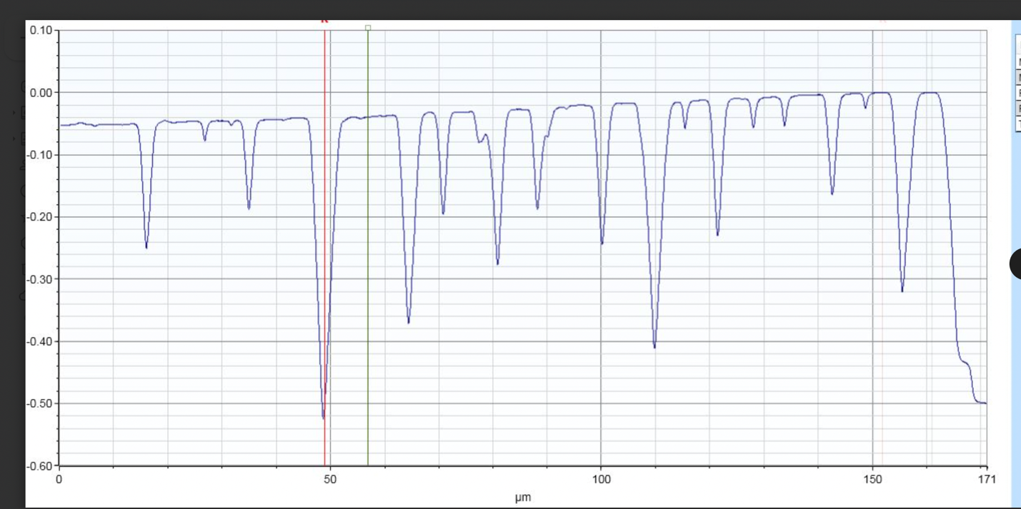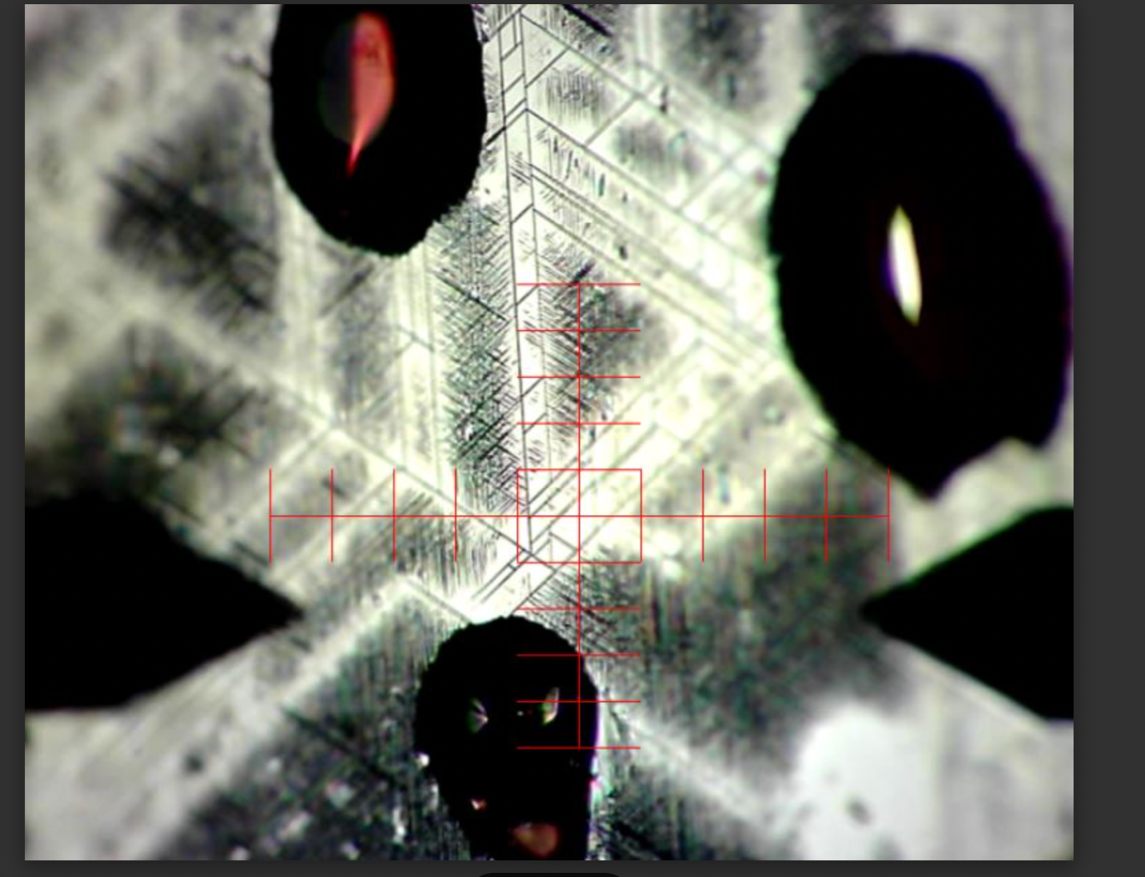

With this non uniform etching, it is unclear what the rate if etching is for this material/etchant combination. But it is nevertheless etching too rapidly for our purposes. I can see this trenching phenomena as being useful for some other purpose however.

All the data can be found on the CEN drive.